A000-MEX-Maya-Death and Life-900 CE

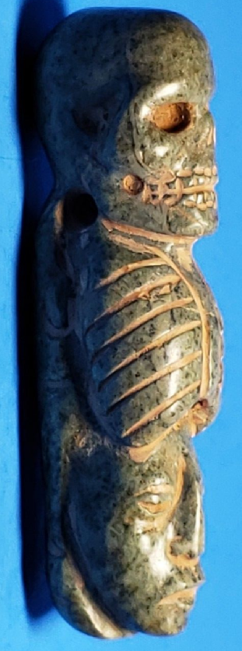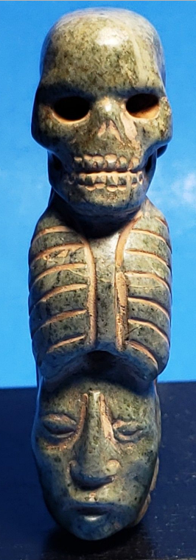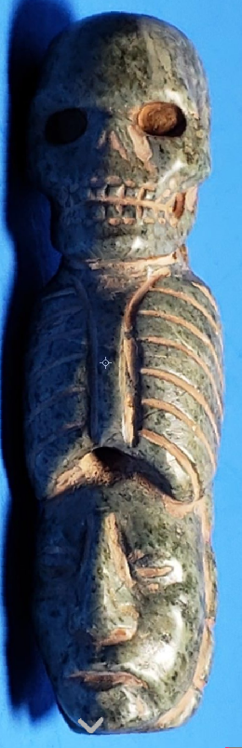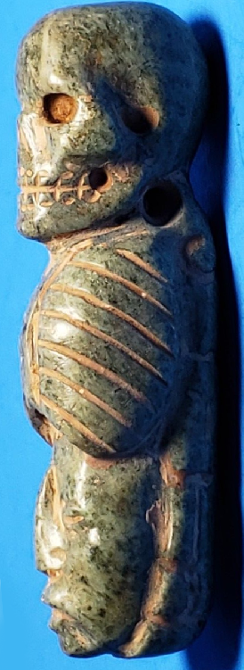

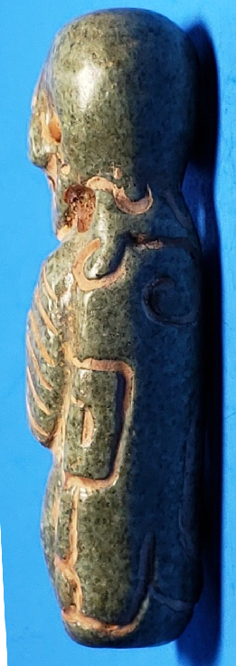

Figs. 1-5. Maya-Death and Life-900 CE

**Case No.: 10**

**Accession No.**

**Formal Label: Maya-Life-Death Duality Pendant**

**Display Description:**

Life-death duality was represented either by means of a face; half side of it being alive and the other fleshless, or using two heads. The calendar and cult to the Gods along the year, were others ways to express such duality, where the most basic needs of the Maya were captured: agriculture as life and war as an expression of death.

**Accession Number:**

**LC Classification:**

**Date or Time Horizon:**

**Geographical Area:**

**Map:**

**GPS coordinates:**

**Cultural Affiliation:**

**Media:**

**Dimensions:**

**Weight:**

**Condition:**

**Provenance:**

**Discussion:**

**References:**